CS 499 Module One Assignment Template

Complete this template by replacing the bracketed text with the relevant information.

- Self-Introduction: Address all of the following questions to introduce yourself.

  - How long have you been in the Computer Science program?

My enrollment in the Computer Science program at Southern New Hampshire University has extended over several years. I started in October 2022 after my father passed away, during which I simultaneously managed full-time employment and personal responsibilities. The curriculum has provided comprehensive instruction across various core areas, specifically encompassing software development, database management, data structures and algorithms, full-stack development principles, secure coding practices, software engineering methodologies, and system design concepts. This academic endeavor has been instrumental in cultivating both my technical proficiencies and professional competencies, thereby effectively preparing me for career paths in software engineering and full-stack application development.

  - What have you learned while in the program? List three of the most important concepts or skills you have learned.

Throughout the program, my studies emphasized acquiring proficiency in full-stack web development, principles of database design and management, and effective algorithmic problem solving.

Courses like CS-465 Full Stack Development provided insight into the collaborative nature of frontend and backend technologies in building comprehensive web applications. This involved practical application using frameworks and tools such as Angular, Node.js, Express, REST APIs, and MongoDB.

My practical experience also included extensive work with database systems, encompassing both SQL and NoSQL environments. Key competencies gained involved designing database schemas, performing CRUD operations, optimizing query performance, and seamlessly integrating these databases within full-stack application architectures.

Furthermore, my coursework significantly deepened my knowledge of algorithms and data structures, specifically covering search and sorting methodologies, efficiency analysis, and object-oriented programming principles. This enhanced comprehension has proven crucial for optimizing application performance and formulating designs for scalable software solutions.

  - Discuss the specific skills you aim to demonstrate through your enhancements to reach each of the course outcomes.

This project is designed to illustrate my advanced proficiencies across several key areas of full-stack software engineering. Specifically, it aims to demonstrate my understanding of secure coding practices, effective database integration, sophisticated API development, and critical performance optimization techniques, all complemented by strong professional communication abilities.

Within the domain of software engineering and design, I intend to highlight specific competencies. These include the implementation of a modular architecture, seamless integration between frontend and backend components, a responsive user interface design, robust authentication security measures, and a well-structured, maintainable code organization.

Pertaining to algorithms and data structures, I will illustrate the application of efficient search and filtering techniques. Additionally, I will showcase optimized data-handling strategies that, by leveraging fundamental algorithmic principles, improve application performance.

Regarding database implementation, this project will showcase advanced integration with MongoDB. This involves demonstrating proficiency in schema validation, effective indexing strategies, comprehensive CRUD operations, and various techniques for database optimization.

Finally, my communication and collaboration abilities will be evident through several artifacts. These include detailed code reviews, comprehensive written narratives accompanying the code, the structured organization of my GitHub portfolio, and a reflective professional self-assessment.

  - How do the specific skills you will demonstrate align with your career plans related to your degree?

The competencies demonstrated through these improvements directly correspond with my professional aspirations in software engineering and full-stack web development. My objective is to build a career encompassing modern web applications, backend infrastructure, secure software architecture, and database-centric development.

These improvements will illustrate practical competencies sought by employers, such as frontend and backend development, API integration, security protocols, database administration, debugging, problem resolution, and application optimization. Furthermore, these projects will underscore my capacity for independently evaluating software systems and implementing substantive enhancements.

  - How does this contribute to the specialization you are targeting for your career?

This ePortfolio directly reflects my specialized interests in full-stack software engineering and secure application development. The enhancements within these projects highlight key areas such as modern web technologies, robust backend architecture, secure authentication systems, efficient database integration, and thorough performance optimization.

The portfolio is designed to showcase my capabilities in developing and refining comprehensive software systems, moving beyond isolated assignments. Such a demonstration is highly pertinent to professional software engineering positions that require expertise in developing scalable web applications, implementing secure coding practices, and managing database-driven systems effectively.

- ePortfolio Set Up:

  - Submit a screen capture of your ePortfolio GitHub Pages home page that clearly shows your URL.
    - You already have a repository in GitHub where you uploaded projects in previous courses. Your ePortfolio will reside in GitHub but can link to work at other sites, such as Bitbucket.

  - Use the GitHub Pages link in the Resource section for directions on:
    - How to create your GitHub website and publish code to GitHub Pages
    - Issues, such as adding links to other sites

  - Paste a screenshot of your GitHub Pages home page with your URL clearly showing in the space below.

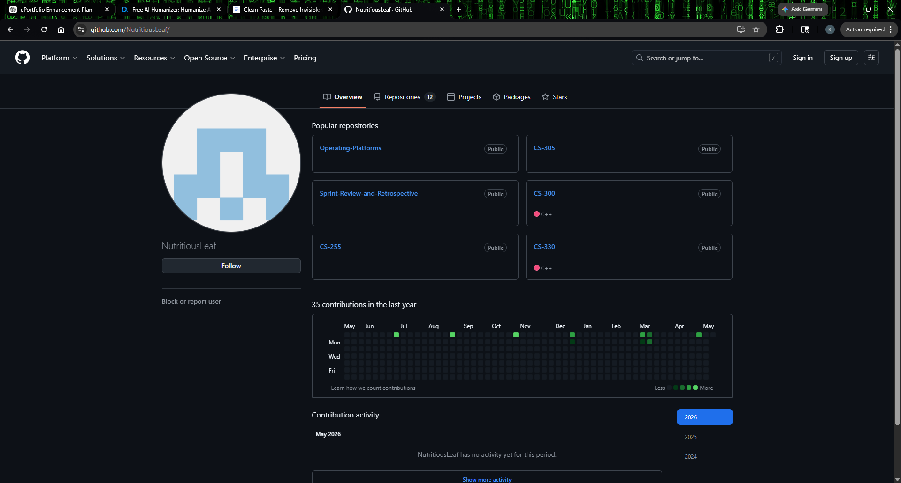

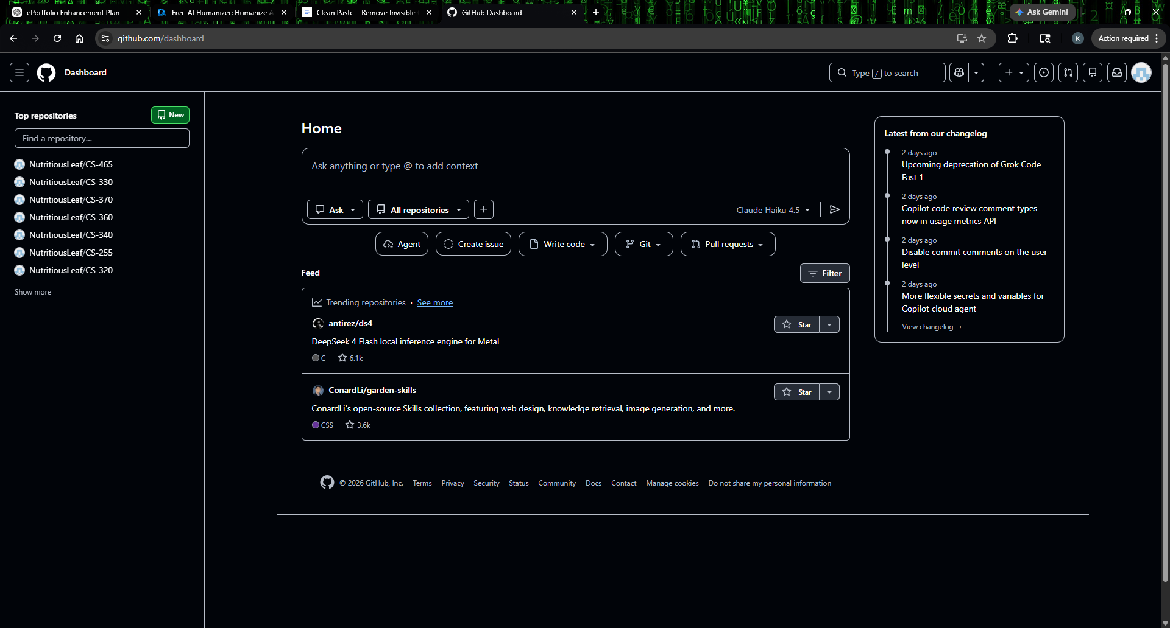

- Enhancement Plan:

  - Category One: Software Engineering and Design
    - Select an artifact that is aligned with the software engineering and design category and explain its origin. Submit a file containing the code for the artifact you choose with your enhancement plan.

For the software engineering and design section, I've chosen my 'Travlr Getaways' application. This is a full-stack travel application that I developed during the CS-465 Full Stack Development course. It features a customer-facing website built with Express and Handlebars, complemented by an administrative single-page application using Angular. Both are linked via a Node.js and Express backend, which integrates with MongoDB.

My decision to select this particular artifact stems from its comprehensive illustration of various full-stack software engineering principles. These include aspects such as frontend development, the creation of backend APIs, managing authentication, implementing routing, designing modular applications, and integrating databases.

Note: Your artifact may be work from the following courses:

- IT 145: Foundation in Application Development
- CS 250: Software Development Lifecycle
- CS 260: Data Structures and Algorithms
- IT 315: Object Oriented Analysis and Design
- CS 320: Software Testing, Automation, and Quality Assurance
- CS 330: Computational Graphics and Visualization
- CS 340: Advanced Programming Concepts
- CS 350: Emerging Systems Architectures and Technologies
- CS 360: Mobile Architecture and Programming
- IT 365: Operating Environments
- IT 380: Cybersecurity and Information Assurance
- CS 405: Secure Coding
- CS 410: Reverse Software engineering
- IT 340: Network and Telecommunication Management
- IT 380: Cybersecurity and Information Assurance

    - Describe a practical, well-illustrated plan for enhancement in alignment with the category, including a pseudocode or flowchart that illustrates the planned enhancement.

To advance the application's engineering and design, my objective is to refine its core architecture, enhance its overall usability, boost its maintainability, and strengthen its security posture.

The proposed enhancements involve a series of initiatives, notably:

-Undertaking a refactoring of both frontend and backend components to establish more distinct and modular structures
-Optimizing the organization of Angular components for greater clarity and efficiency
-Implementing more robust form validation mechanisms alongside refined error handling protocols
-Strengthening the existing JWT authentication and authorization processes
-Refining the user interface design to ensure it is fully responsive across various devices
-Generating more comprehensive documentation and incorporating explicit in-code comments
-Bolstering security protocols specifically for the application's API endpoints
-Streamlining the application's navigation pathways to enhance overall user experience and ease of use

START APPLICATION

IF user attempts login
Validate credentials
Generate secure JWT token
Store token securely
Redirect to admin dashboard
ELSE
Display authentication error
END IF

FOR each API request
Verify JWT token
Validate request data
Process CRUD operation
Return response
END FOR

FOR each frontend component
Validate user input
Display loading/error states
Update UI dynamically
END FOR

END APPLICATION

For this category of enhancement, consider improving a piece of software, transferring a project into a different language, reverse engineering a piece of software for a different operating system, or expanding a project’s complexity. These are just recommendations. Consider being creative and proposing an alternative enhancement to your instructor.

Think about what additions to include to complete the enhancement criteria in this category. Since one example option is to port to a new language, that is the kind of scale that is expected. This does not mean you need to port to a new language, but instead have an equivalent scale of enhancement. Underlying expectations of any enhancement include fixing errors, debugging, and cleaning up comments, but these are not enhancements themselves.

    - Explain how the planned enhancement will demonstrate specific skills and align with course outcomes.

      - Identify and describe the specific skills you will demonstrate that align with the course outcome.

This enhancement will demonstrate:
-Full-stack application development
-Angular frontend development
-REST API integration
-Secure authentication practices
-Modular software architecture
-Responsive UI design
-Software testing and debugging
-Professional documentation practices

      - Select one or more of the course outcomes below that your enhancement will align with.

This enhancement aligns with Course Outcomes 2, 3, 4, and 5.

Course Outcomes:

- Employ strategies for building collaborative environments that enable diverse audiences to support organizational decision-making in the field of computer science.
- Design, develop, and deliver professional-quality oral, written, and visual communications that are coherent, technically sound, and appropriately adapted to specific audiences and contexts.
- Design and evaluate computing solutions that solve a given problem using algorithmic principles and computer science practices and standards appropriate to its solution while managing the trade-offs involved in design choices.
- Demonstrate an ability to use well-founded and innovative techniques, skills, and tools in computing practices for the purpose of implementing computer solutions that deliver value and accomplish industry-specific goals.
- Develop a security mindset that anticipates adversarial exploits in software architecture and designs to expose potential vulnerabilities, mitigate design flaws, and ensure privacy and enhanced security of data and resources.

  - Category Two: Algorithms and Data Structures

- Select an artifact that is aligned with the algorithms and data structures category and explain its origin. Submit a file containing the code for the artifact you choose with your enhancement plan. You may choose work from the courses listed under Category One.

For the algorithms and data structures component, the 'Travlr Getaways' application, originally from CS-465 Full Stack Development, will remain the selected platform. This decision is based on its capacity to facilitate enhancements in application efficiency and the integration of more sophisticated data handling techniques.

- Describe a practical, well-illustrated plan for enhancement in alignment with the category, including a pseudocode or flowchart that illustrates the planned enhancement.

For this enhancement, I plan to improve the effectiveness and scalability of trip searching, filtering, and sorting operations within the application.

INPUT user search query

FETCH trip collection

FOR each trip in collection
IF trip matches search criteria
Add to filtered results
END IF
END FOR

SORT filtered results alphabetically

DISPLAY optimized results to user

For this category of enhancement, consider improving the efficiency of a project or expanding the complexity of the use of data structures and algorithms for your artifact. These are just recommendations. Consider being creative and proposing an alternative enhancement to your instructor. Note: You only need to choose one type of enhancement per category.

Think about what additions to include to complete the enhancement criteria in this category. Since one example option is to port to a new language, that is the kind of scale that is expected. Perhaps you might increase the efficiency and time complexity of an algorithm in an application and detail the logic of the increased time complexity. Remember, you do not need to port to a new language but instead have an equivalent scale of enhancement. Underlying expectations of any enhancement include fixing errors, debugging, and cleaning up comments, but these are not enhancements themselves.

- Explain how the planned enhancement will demonstrate specific skills and align with course outcomes.

  - Identify and describe the specific skills you will demonstrate to align with the course outcome.

-Algorithm optimization
-Data structure implementation
-Search and sorting techniques
-Performance analysis
-Complexity reduction
-Efficient frontend rendering
-API efficiency improvements

  - Select one or more of the course outcomes listed under Category One that your enhancement will align with.

This enhancement aligns with Course Outcomes 3 and 4.

  - Category Three: Databases

    - Select an artifact that is aligned with the databases category and explain its origin. Submit a file containing the code for the artifact you choose with your enhancement plan. You may choose work from the courses listed under Category One.

Regarding the database component, I plan to leverage the MongoDB integration found within the “Travlr Getaways” full-stack application, which was developed during the CS-465 Full Stack Development course.

This existing artifact already encompasses critical database functionalities, including comprehensive trip storage, standard CRUD operations, and established Mongoose schemas. These inherent capabilities position it effectively for further advanced database enhancements.

    - Describe a practical, well-illustrated plan for enhancement in alignment with the category, including a pseudocode or flowchart that illustrates the planned enhancement.

I plan to expand and optimize the MongoDB database layer used by the application.
-Improved schema validation
-MongoDB indexing for performance optimization
-Expanded CRUD functionality
-Better error handling
-Improved database security practices
-Additional database relationships and collections
-Optimized queries and API integration

CONNECT to MongoDb database

DEFINE enhanced schema validation rules

IF new trip submitted
Validate all required fields
Save trip to database
ELSE
Return validation error
END IF

CREATE indexes for frequently searched fields

OPTIMIZE query performance

RETURN database results to frontend

For this category of enhancement, consider adding more advanced concepts of MySQL, incorporating data mining, creating a MongoDB interface with HTML/JavaScript, or building a full stack with a different programming language for your artifact. These are just recommendations; consider being creative and proposing an alternative enhancement to your instructor. Note: You only need to choose one type of enhancement per category.

Think about what additions to include to complete the enhancement criteria in this category. Since one example option is to port to a new language, that is the kind of scale that is expected. Perhaps you might increase the efficiency and time complexity of an algorithm in an application and detail the logic of the increased time complexity. Remember, you do not need to port to a new language but instead have an equivalent scale of enhancement. Underlying expectations of any enhancement include fixing errors, debugging, and cleaning up comments, but these are not enhancements themselves.
    - Explain how the planned enhancement will demonstrate specific skills and align with course outcomes.

      - Identify and describe the specific skills you will demonstrate that align with the course outcome.

-MongoDB database management
-Schema design
-CRUD operations
-Query optimization
-Database security
-Backend integration
-RESTful API development

      - Select one or more of the course outcomes listed under Category One that your enhancement will align with.

This enhancement aligns with Course Outcomes 3, 4, and 5.

- ePortfolio Overall Skill Set

  - Accurately describe the skill set to be illustrated by the ePortfolio overall.
    - Skills and outcomes planned to be illustrated in the code review

The code review will illustrate my command of key areas such as software architecture, debugging techniques, the integration of frontend and backend systems, security considerations, the overall application flow, and strategies for software improvement. It will also demonstrate my ability to clearly communicate complex technical concepts to a professional audience.

    - Skills and outcomes planned to be illustrated in the narratives

The narratives will illustrate my capacity to reflect critically on my technical development, clearly explain design decisions, discuss encountered challenges and their practical solutions, and communicate software engineering concepts professionally. They will further demonstrate how the various enhancements align with the specified learning outcomes of the course and established industry practices.

    - Skills and outcomes planned to be illustrated in the professional self-assessment

This professional self-assessment is designed to showcase the development I have undergone throughout the Computer Science program. Specifically, it will address my advancements in technical proficiency, problem-solving aptitude, secure coding practices, collaborative work, communication effectiveness, and comprehensive full-stack software engineering capabilities. Moreover, it aims to delineate how my academic studies and supplementary experiences collectively confirm my readiness for a professional trajectory in computer science.

